1. In Internet Explorer (IE) log on to SSP by typing:

SSP from the USPS Blue page or <https://ssp.usps.gov> from your home computer

Response: SSP Welcome page

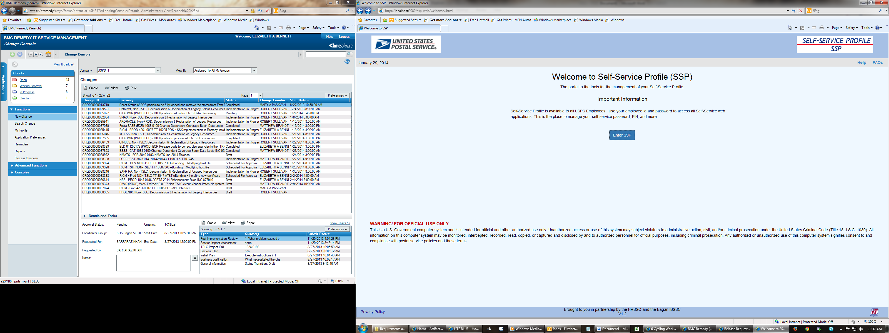

1. Click on Enter SSP button.

Response: SSP Login page

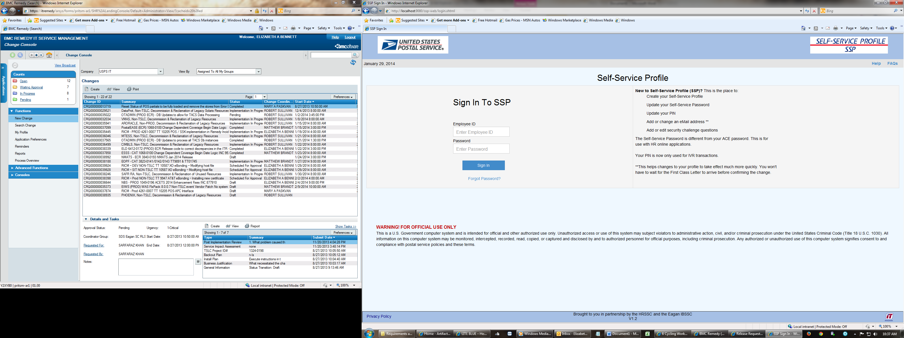

1. Enter Employee ID and SSP Password.

(If you do not know your SSP Password click on the Forgot Password? link and then see Step 4)

Response: SSP Manage Profile page

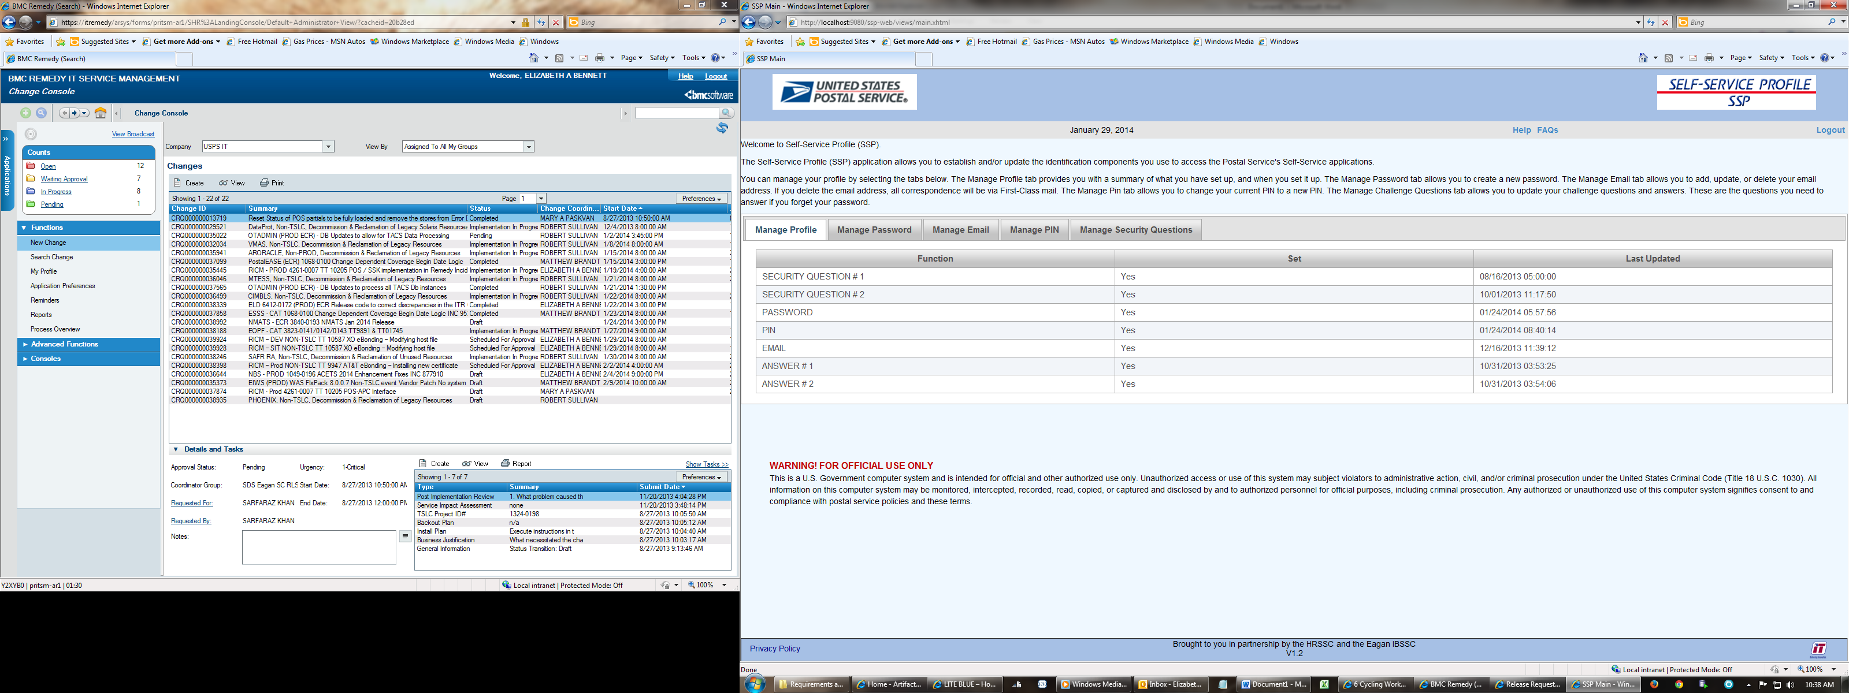

1. If you clicked on the Forgot Password? link at the bottom of the SSP Login page.

Response: EIN Verification page

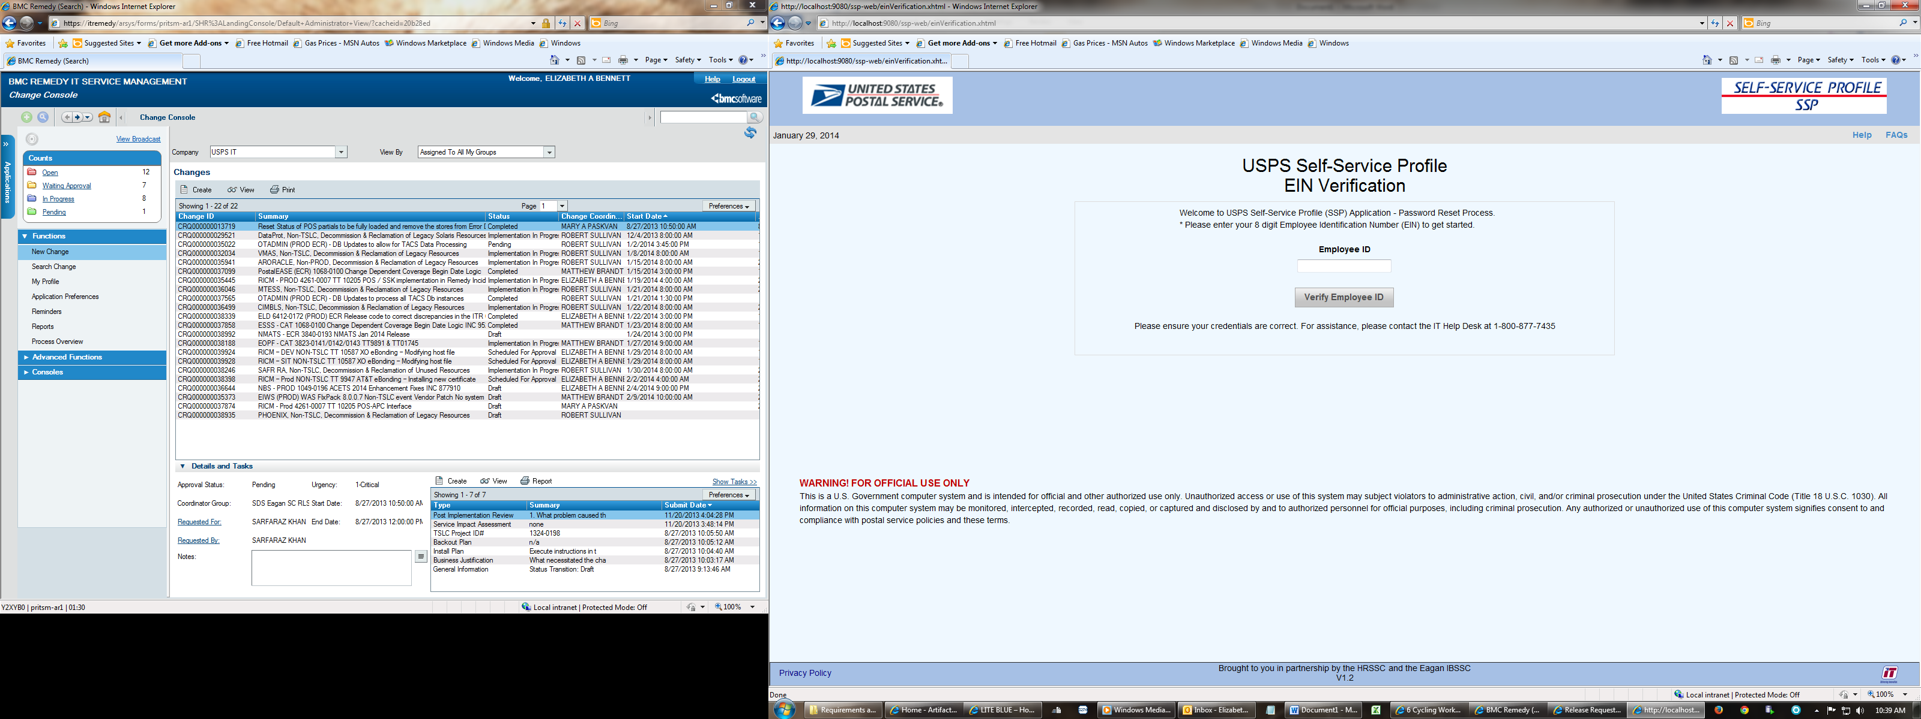

1. Enter your EIN and click Verify Employee ID

Response: SSP Password Reset – Security Questions page

(This screen only appears if you have previously set up your Self Service Profile – Otherwise see Step 9.)

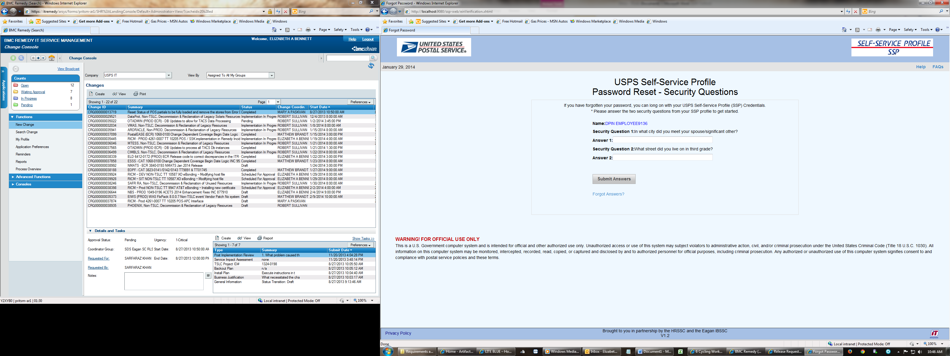

1. Your selected questions are displayed enter your answers.

Click the Submit Answers.

Response: Password Reset Screen

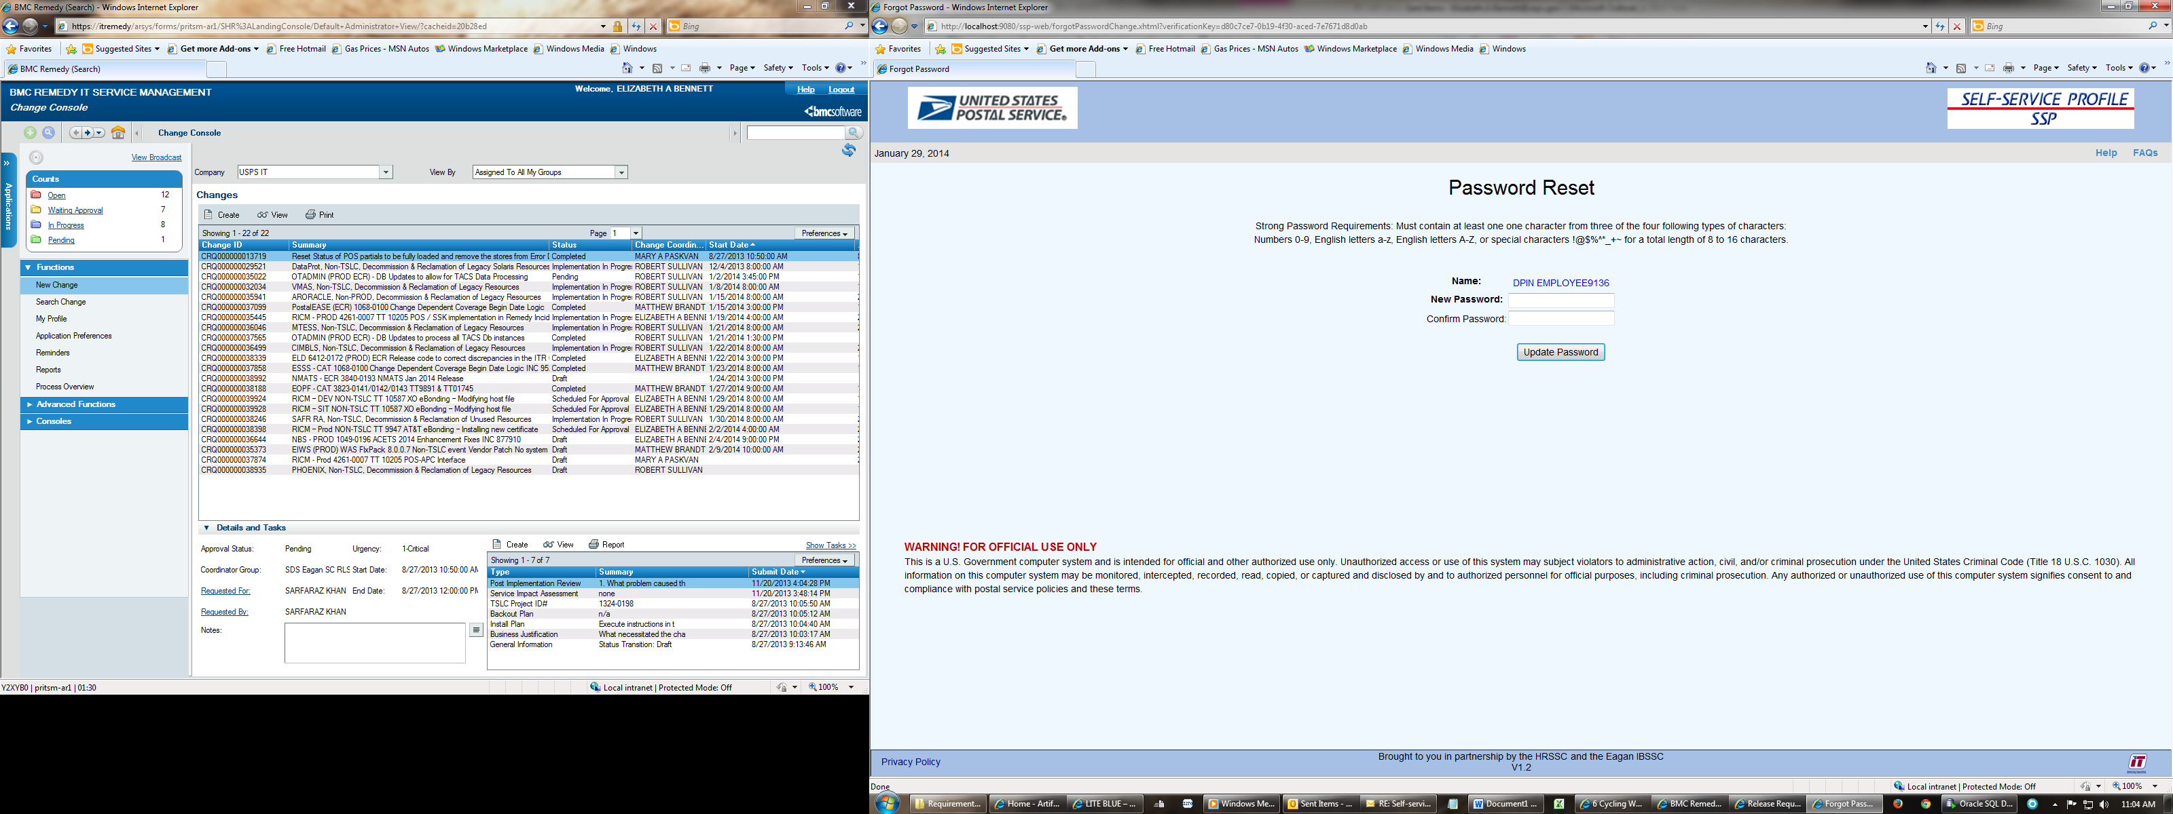

1. Your name should appear.

Enter New Password and Confirm Password.

Click Update Password.

Response: SSP Login page



1. You can now log in to SSP or go to one of the HR Self Service WEB application such as LiteBlue or PostalEASE. Your password has been updated.

If you log into SSP.

Response: SSP Manage Profile page



1. If you are logging into SSP for the first time you will need to set up your Self Service Profile.

Response: Self Service Profile Setup Set Password Tab

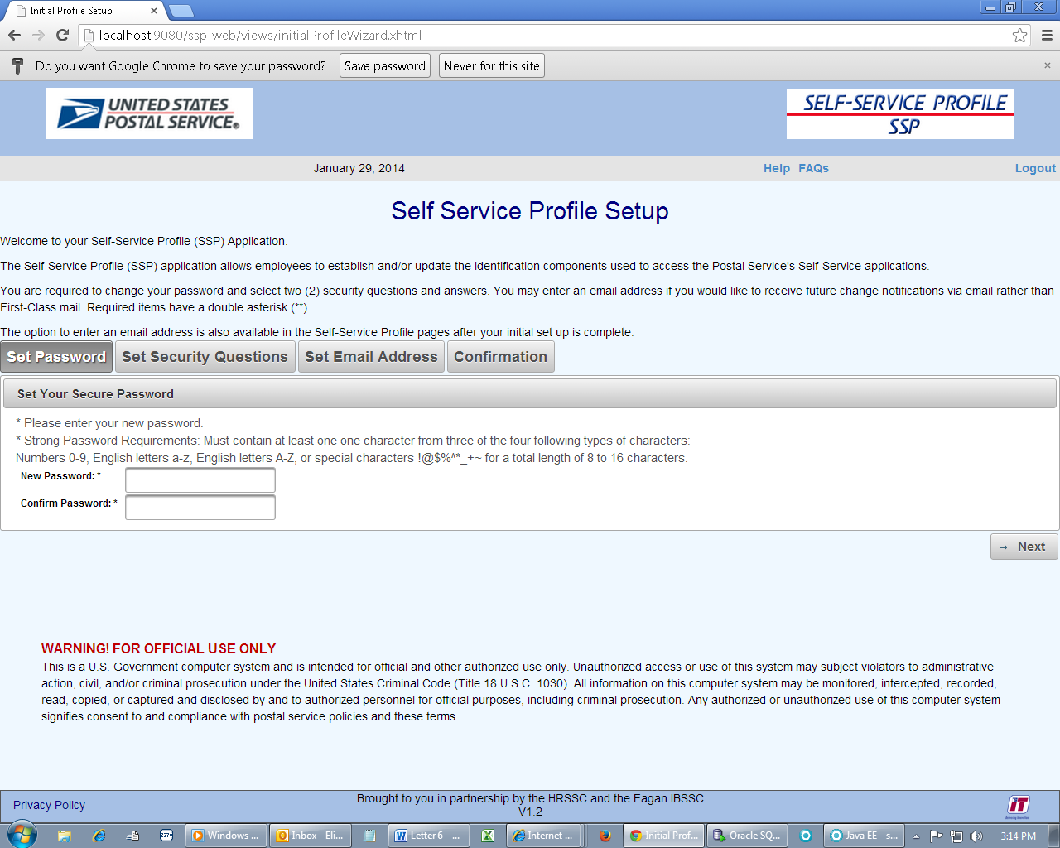

1. Enter New Password and Confirm Password.

Follow the strong password rules.

Click on the Next button.

Response: Self Service Profile Setup Set Security Questions Tab

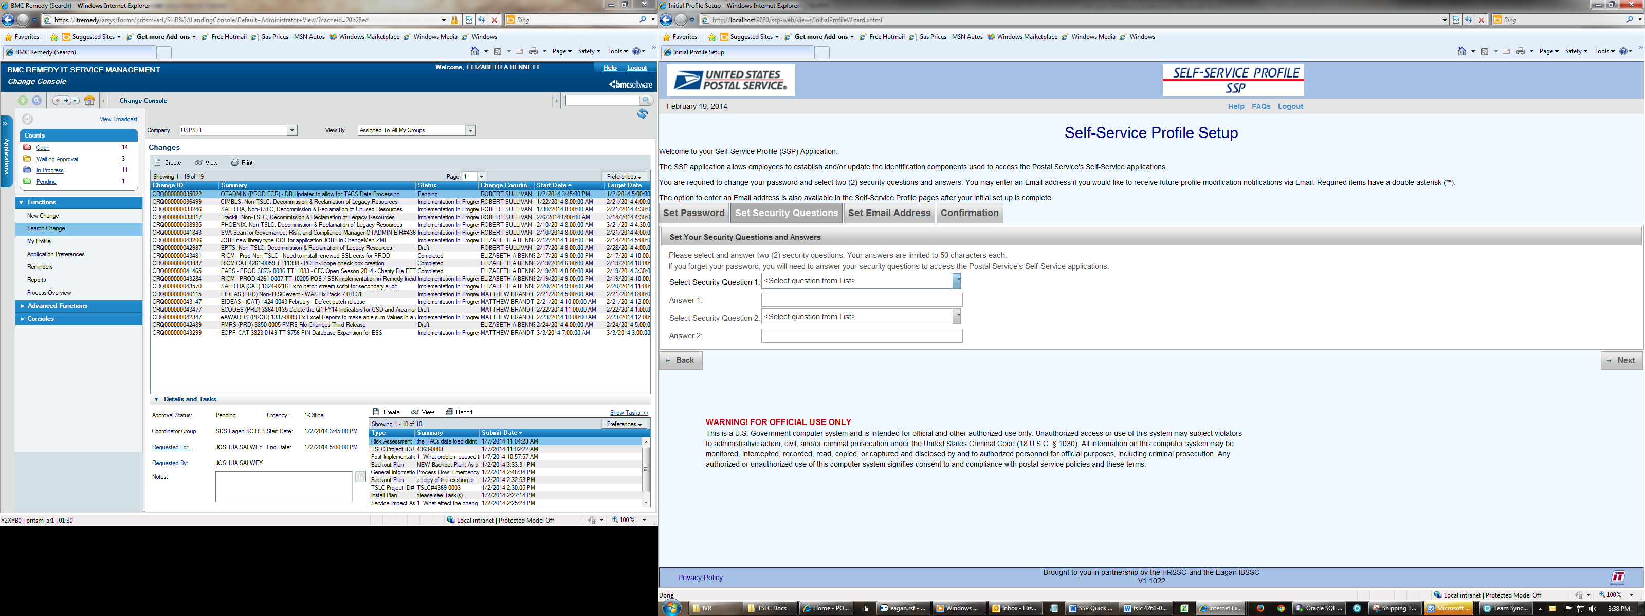

1. Select Questions from the dropdown lists and enter your answers.

Click on the Next button.

Response: Self Service Profile Setup Set Email Tab

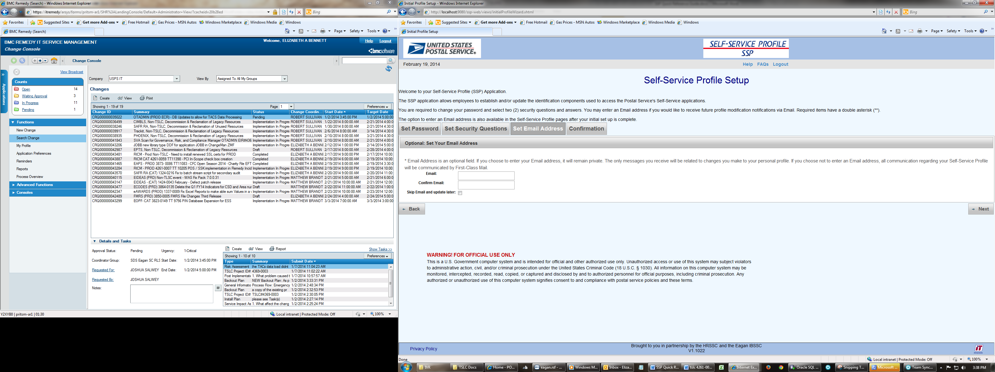

1. Enter your Email and Confirm Email.

Click on the Next button.

Response: Self Service Profile Confirmation Tab 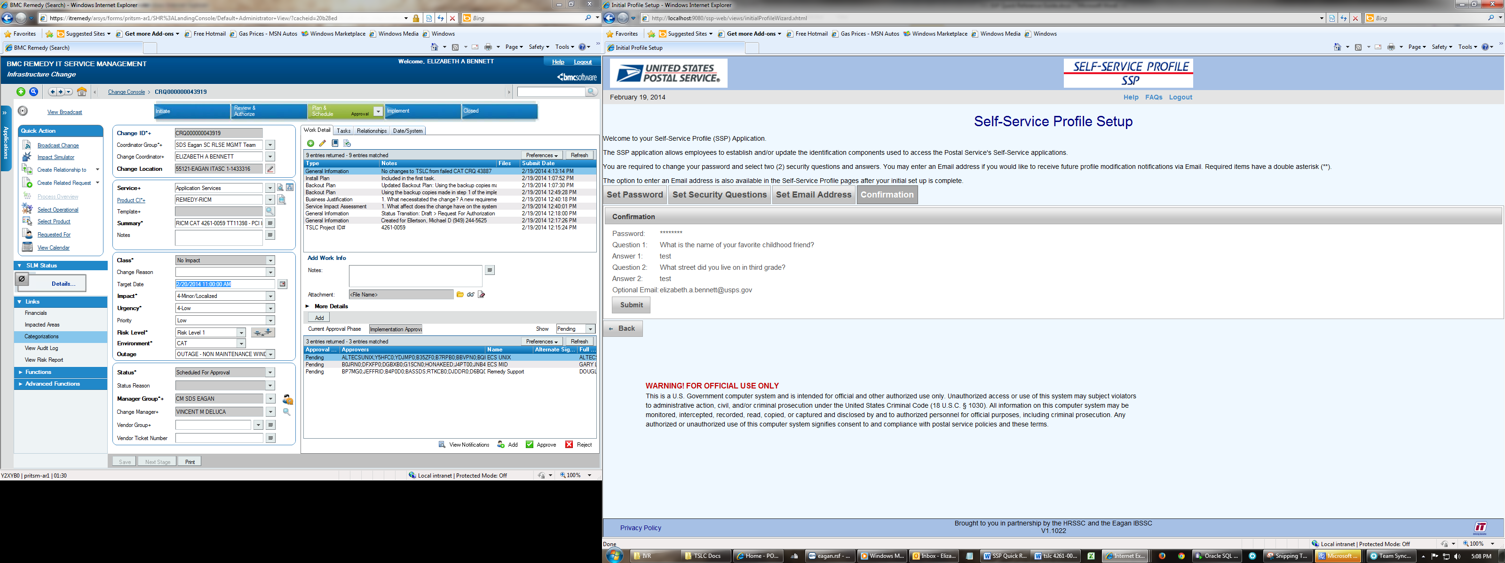

1. You can choose not to enter an email by putting a check in “Skip Email and update later” check box.

Response: Self Service Profile Confirmation Tab (no email)

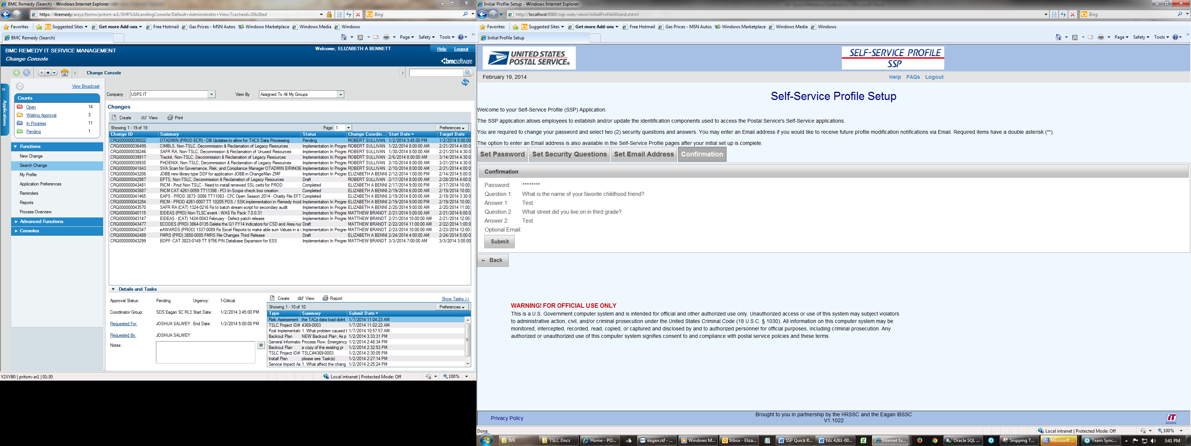

1. If everything on the Confirmation page is correct.

Click on the Submit Button.

Response: SSP Manage Profile page



1. If there is nothing else in SSP that you plan to manage

Click on the Logout Link on the menu bar.

Response: SSP Login page



1. If all ITSH resources exhausted contact Human Resources Shared Service Center (HRSSC) by calling the Employee Service line1-877-477-3273, and selecting option 5 or TDD/TTY - 866-260-7507.

